PENNSTATE Report Template

Department of _____________ Engineering



**Show Team name and Report name**

**(Indicate: Proposal, DSR/Progress, or Final Report)**

Date (Times New Roman, 12)

Show representative picture of project on front page

First Author (Times New Roman, 12)

Second Author (Times New Roman, 12)

Third Author (Times New Roman, 12)

Fourth Author (Times New Roman, 12)

At the bottom left of title page, be sure to indicate whether or not IP and NDA apply:

|  |  |
| --- | --- |
| ◻ or ☑ | Intellectual Property Rights Agreement Applies |
| ◻ or ☑ | Non-Disclosure Agreement Applies |

**Executive Summary (Times New Roman 16, Bold, left)**

The report should start with an Executive Summary (or also known as an Abstract) of approximately 200-400 words, summarizing the objective, contents, results, and conclusions as specifically as possible. The heading of the Executive Summary should be italic. This section **MUST** be updated for subsequent reports. An executive may read only this section, so summarize the major results of this report here!

**Table of Contents(Times New Roman 16, Bold, left)**

List paragraph numbers and indented subparagraph numbers and topic names in a column. Also list the appropriate page numbers of the paragraphs on the right side of the page.

**1.0 Introduction (Times New Roman 16, Bold, left)**

The entire body text of the report should be Times New Roman, 10, and justified. Major headings should be numbered consecutively, 1.0, 2.0, 3.0, etc, typed in bold face with a font size of 16. Sub-headings should be numbered consecutively, 1.1, 1.2, etc, and typed in bold face with a font size of 14. Finally, sub-sub-headings should also be numbered consecutively, 1.1.1, 1.1.2, etc., and typed in bold face with a size 12 font face. It is not recommended to go beyond three levels of headings.

Use the introduction section to provide some background information on your project. This introductory information should come from your literature search – Library, Internet, trade magazines, etc. The sources of all text that is not your own ideas should be referenced. For your reports please use the *parenthetical references: author-date system* (Ogot and Kremer, 2004, pg.71).

A sample reference list addressing each of the five main types of information sources is given at the end of this document. These include: websites (Swanson, 1999), journals (Muriru and Daewoo, 2002), books (Zacharia and Daudi, 2001), conference proceedings (Peters et al., 2001) and patents (Wen-Cheng, 1994).

Finally, make sure that your report has page numbers from the second page through the appendix. This is often forgotten. Correct presentation is essential, so turn in a professionally written report!

**1.1 Initial Problem Statement (Times New Roman, 14, left)**

Provide a brief paragraph describing your initial problem statement and the importance or significance of the problem. Provide background information to educate the reader. Most of this section should come from the problem statement that you were issued. Supply a brief description of the company, if applicable.

**1.2 Objectives**

Provide in paragraph form a general explanation of what you expect your design will and will not show or accomplish. This section contains the scope of work and limitations of your future design. (This is a difficult paragraph to write, but ensures that you are thinking clearly on general objectives and how you intend to address them.)

**2.0 Customer Needs Assessment**

**2.1 Gathering Customer Input**

This section will describe the manner in which customer needs where gathered.

**2.2 Weighting of Customer Needs**

To create a weighted hierarchal customer needs list use AHP. Guidelines on AHP can be found on the course web site on Angel. This section should begin with a brief introduction, on importance of weighting, and then provide AHP tables that shows how the weights were calculated (refer to Table 1). The AHP calculations must be done in MS Excel as the table can be selected, cut-and-paste from Excel into your report, making your life easier. All figures are numbered consecutively with figure captions typically placed at the bottom of the figure.

Please make sure you press the ‘Shift’ key *before* you select the commands *Edit>Copy* to copy the table. By pressing the *shift* key the commands change to *Copy Picture,* whereby Excel copies the table as a picture, not a worksheet. As a result it is much clearer in your report.

At a minimum, include a table listing the hierarchal customer needs *objective* list that has been augmented with *constraints* and *functions* (refer to Table 2). Note that the constraints and functions are formatted differently for easy identification. Next to objective is pair of numbers denoting absolute and relative weight. **Explain** your weightings and the results in writing. In summary the categories are: Objectives define the attributes, Functions are features it must do, and Constraints are limits. All table captions are placed on *top* of the tables and the tables are numbered consecutively. Please make sure that a table is not split between two pages. Move the table to a location where it can fit. If the table is too big to fit, split the table into two separate tables with separate table numbers and captions.

**Table 1. AHP Pairwise Comparison Chart to Determine Weighting for Main Objective Categories**

|  |  |  |  |  |  |  |  |  |  |  |
| --- | --- | --- | --- | --- | --- | --- | --- | --- | --- | --- |
|  | **Safe** | **Ease of Use** | **Ease of Mfg** | **Cost** | **Eff.** | **Dur.** | **Port.** | **Ergo.** | **Total** | **Weight** |
| Safe | 1.00 | 1.00 | 0.33 | 2.00 | 0.33 | 0.50 | 3.00 | 5.00 | 13.16 | 0.13 |
| Ease of Use | 1.00 | 1.00 | 1.00 | 0.33 | 1.00 | 1.00 | 4.00 | 4.00 | 13.33 | 0.13 |
| Ease of Mfg | 3.00 | 1.00 | 1.00 | 3.00 | 1.00 | 2.00 | 4.00 | 5.00 | 20.00 | 0.20 |
| Cost | 0.50 | 3.00 | 0.33 | 1.00 | 4.00 | 0.33 | 0.33 | 2.00 | 11.49 | 0.12 |
| Efficient | 3.00 | 1.00 | 1.00 | 3.00 | 1.00 | 3.00 | 4.00 | 5.00 | 21.00 | 0.21 |
| Durable | 2.00 | 1.00 | 0.50 | 3.00 | 0.33 | 1.00 | 2.00 | 3.00 | 12.83 | 0.13 |
| Portable | 0.33 | 0.25 | 0.25 | 0.50 | 0.25 | 0.50 | 1.00 | 0.50 | 3.58 | 0.04 |
| Ergonomic | 0.20 | 0.25 | 0.20 | 0.33 | 0.20 | 0.33 | 2.00 | 1.00 | 4.51 | 0.05 |

**Table 2. Weighted Hierarchal Customer Needs List**

1. Safe (0.13, 0.13)
   1. Moving Parts Concealed (0.0325, 0.25)
   2. Blades Concealed (0.065, 0.5)
   3. No Pinch Points (0.0325, 0.25)

*F.1 Guarded*

1. Ease of Use (0.13, 0.13)
   1. Loading and unloading locations easily accessible (0.039, 0.3)

2.2 Simply Powered (manually) (0.065, 0.5)

2.3 Appropriate places accessible for cleaning (0.026, 0.2)

*F.2 Powered by bicycle or hand crank*

**C.1 Power Requirement must be feasible for an average person**

1. Ease of Manufacturing (0.20, 0.20)
   1. Simple Components (0.10, 0.5)
   2. System easy to assemble (0.10, 0.5)

**C.2 Components available in Jamaica**

**C.3 Machining must be able to be completed in Jamaica**

4. Cost (0.12, 0.12)

4.1 Inexpensive Components (0.066, 0.55)

4.2 Economical when in operation (0.054, 0.45)

5. Efficient (0.21, 0.21)

5.1 Minimize downtime/jams (0.105, 0.5)

5.2 Long life, reduce frequency of replacement parts (0.105, 0.5)

*F.3 High Energy output to input ratio*

6. Durable (0.13, 0.13)

6.1 Parts have long life (0.0325, 0.25)

6.2 Sturdy materials (0.052, 0.4)

6.3 Avoid excessive vibrations/repeated loading (0.013, 0.10)

6.4 Accounting for possible mistreatment of system (0.0325, 0.25)

7. Portable (0.04, 0.04)

7.1 System is light (0.02, 0.5)

7.2 System components kept compact (0.02, 0.5)

*F.4 System is mounted on a moveable source*

8. Ergonomic (0.05, 0.05)

8.1 Repeated use by operator does not lead to strain (0.025, 0.5)

8.2 Manual power source is comfortable for continuous operation (0.025, 0.5)

**C. 4 Maximum Budget is $1000**

**3.0 External Search**

You should also perform a patent search to determine the key technologies used in project area. Focus on utility patents (looking at function) and not aesthetic patents (focusing on artistic design). The external search also looks at what products are already on the market. These should be benchmarked along criteria determined by the group. The results of the benchmarking should be summarized neatly in a table. Engineers in industry spend a large amount of time gathering background information.

**3.1 Patents**

Do a thorough patent search and document such investigations. A comprehensive search now will save you time and effort later. Also summarize your findings and list an art-function matrix in the appendix. This includes patents not necessarily related directly to your project applications.

**3.2 Existing Products**

Provide informative data as to what is on the market today.

**4.0 Engineering Specifications**

**4.1 Establishing Target Specifications**

Provide an initial set of target values that you established as a starting point for the project. Provide a short paragraph on how and why you chose these values related to the customer’s needs.

**4.2 Relating Specifications to Customer Needs**

Show a Needs-Metrics Matrix in a QFD table that has customer needs, specifications **and** **values**.

**5.0 Concept Generation**

**5.1 Problem Clarification**

In this section show the figure and explanation for the ‘black-box’ model, clearly showing the functions and the energy, material and signal flows through the device. A refined sub-function diagram rather than an overall black box diagram is expected.

**5.2 Concept Generation**

For each of the functions that the design team has chosen to tackle (based on revised problem statement), provide figures for each of the developed concepts. In the body of this section explain the concept. The figures should be SolidWorks (or other software of your choosing) solid models for the top choice and can be neat scanned in sketches for the 3(+) other alternatives.

Document the concept combination table (morphological chart) that was developed from the different concepts for each function (if applicable). If “TRIZ” or “WordTree Design-by-Analogy “ are used and documented, 5 bonus points will be awarded for the SOW. See guidelines posted on the course web site on Angel.

**5.3 Concept Selection**

Discuss and provide the Concept scoring and/or Concept Screening charts that were used to decide which combination of concepts from the morphological chart best met the design teams customer needs. AHP charts for the weighting of the selection criteria must also be included. This design concept becomes the final design that is developed further. A discussion of pros and cons of each design is required.

**6.0 System Level Design**

Your #1 concept should be well illustrated with multiple 3-Dimensional models created in *SolidWorks*. The design should be described in text as well as in drawings.

See the drawing example in Figure 1 as well as the example of the descriptive paragraph:

“The pelletizer system, shown in Figure 1, provides a manual compression force to condense the switchgrass into cubical pellets. Notice the triangular grate (A) at the bottom of the main compaction chamber. This grate will direct all material to the channels of the grating so they can be compressed into cubical pellets. A “cookie cutter” plate (B) is mounted at the bottom of the grate. This plate serves as two purposes: to block the channels when the material is being compressed and to cut the pellets free from the extrusion. The press (C) is made of concrete to provide a heavy weight to increase the compression force upon operation. The lever mechanism (D) is used to lift and apply pressure to the press. This lever has a pivot point to give the operator a mechanical advantage for lifting and compressing the heavy press. A collection area (E) is located under the grate to catch all pellets once they are cut.”

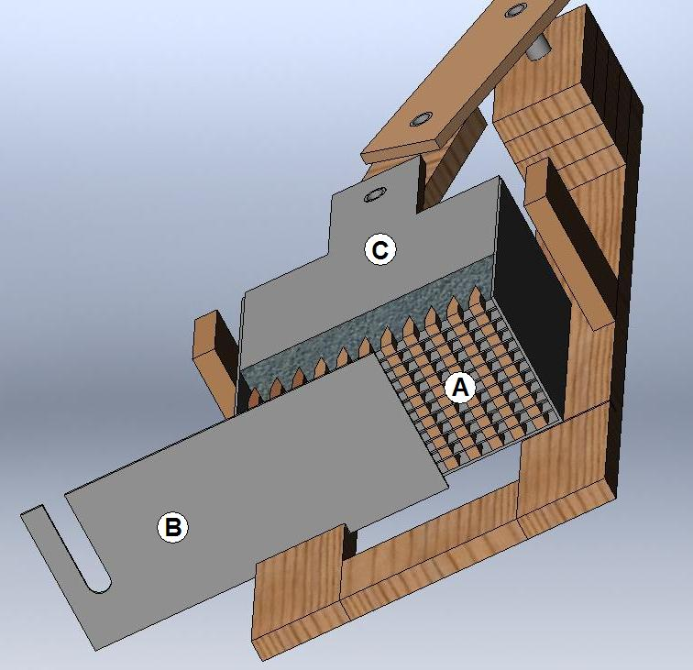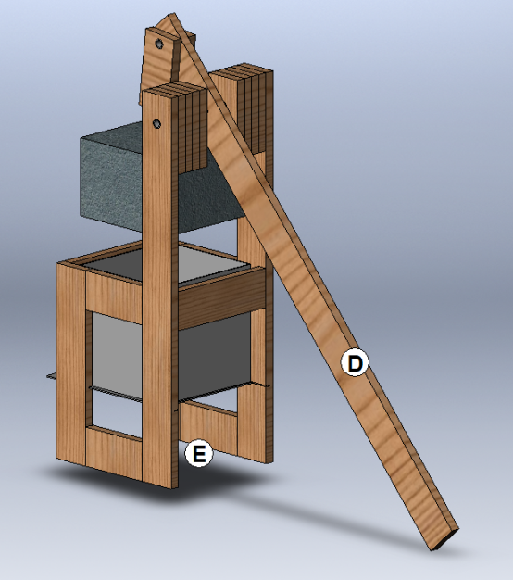

**Figure 1. An example of a 3D CAD model of the final design**

**7.0 Special Topics**

**7.1 Budget and Vendor Purchase Information**

Provide your best estimates on how project funds will be spent. You can always change your budget later as you get further in to the project. This budget will be updated in **each** report as more information is known up to the final report where all funds are known. The Final Report will not contain any estimates as all the information should be completed. Major categories are travel, equipment, supplies, and poster. The Bill of Materials (BOM) should be included in the appendix.

**7.2 Project Management**

A Gantt chart **with** milestones, tasks and responsibilities must be provided as well as a short paragraph introducing the Gantt chart. Show enough detail but keep it to one page. Another part of the project management is the project team capabilities. To illustrate your capabilities, include your resumes in the Appendix. Also include a copy of your deliverables agreement in the appendix. Summarize your management and technical skills and how they will be used to fulfil the customer’s needs. Also provide a brief paragraph of major work that has to be completed before the end of the semester.

**7.3 Risk Plan (if applicable) and Safety**

Discuss how your team will ameliorate or lessen any safety problems, if applicable. Risk factors can be marketing risk, technical risks, manufacturing risks, schedule risks or reliability risks but all are generally reducible to financial risk to the company. Provide a paragraph that describes the risk plan table. See example of Risk Plan in Table 3.

**Table 3. Risk Plan example**

|  |  |  |  |
| --- | --- | --- | --- |
| **Risk** | **Level** | **Actions to Minimize** | **Fall Back Strategy** |
| Change in customer specification | Moderate | -Involve customer in process of refining specifications  -Work with customer to estimate time and cost penalties of changes | -Add time to schedule for that particular task  -Additional budget required |
| Schedule delays | High | -Constantly track project progress  -Look for ways to accelerate activities  -Identify critical path and tasks | -Build in safety time  -Re-allocate resources  or staff |
| Delays in order placement or delivery | Moderate | -Make sure parts are in stock  -Make sure purchasing department has all needed information | -Build it yourself  -Drive to NJ and pick it up |
| Product does not function as predicted | Low | -Test early and often  -Be aware of risks of new technology | -Alternative design  -Different material, technology, etc |
| Customer not satisfied | Moderate | -Understand the customer’s needs (voiced and non-voiced) | -Discuss ways to fix the problem |

**7.4 Ethics Statement (if applicable)**

Provide a paragraph of how your team will abide by established ethical standards. This can be in this section or in the Appendix.

**7.5 Environmental Statement (if applicable)**

Provide a paragraph of how your team will meet or exceed environmental standards. This can be in this section or in the Appendix.

**7.6 Communication and Coordination with Sponsor**

Specify the interaction with your sponsor. Provide a listing of the schedule and the form of communication whether it is visits or conference calls.

**+++++++++++++++++++++++++++++++++++++**

**End of Proposal**

**+++++++++++++++++++++++++++++++++++++**

**8.0 Detailed Design**

**8.1 Manufacturing Process Plan**

Provide a manufacturing process plan. Describe how you plan to build your prototype, and if applicable, a plan for mass producing the final product. Keep in mind DFM /DFA when you are addressing this.

The prototype mfg. plan should involve every step you need to do. It details what one must do to make the part such as purchasing the applicable material, a description of what parts have to be machined and deburred, welded, and the assembly process. The idea of it is that one could follow your plan and make the part by just following your plan and drawings. This can be done in bulletized form or in a table format. If you find that during the assembly process a better way to make it, then annotate this DFM problem in the final report.    
  
EXAMPLE below OR use Table format:  
The following steps provide a detailed manufacturing process plan for the XYZ assembly.   
-**Base Assembly** - Raw stock 2' x 4' x 3/4" sheet ASTM A514 Steel   
  Machine to size on End Mill

Drill, debur with countersink, and tap (4) #10-32 holes

Debur edges using flap wheel

-**Arm Assembly** - Raw stock 1/2" Sq x 12" Yellow Brass   
  Turn to size on Lathe

-**Stator Assembly** - Raw stock 4" x 5" x 1/2" 1010 Steel   
  Cut to size on waterjet

Grit blast

-**Stand** - Raw stock 4" x 2" x 12" 4130 Steel    
  Machine to size on End Mill

Debur edges using telescoping swivel bladed deburring tool

-**Stand and Base** (Finished Assy)   
  TIG weld together

Grit blast

Heat treat

Paint (blue)

-**Final Assy**   
  Bolt together using eight #1/4-20 9/16" CRES SHCS

**8.2 Analysis**

What theoretical analysis was necessary to prove your design? Provide results of any calculations or computer simulations that you did. If you perform a Finite Element Analysis **ensure** that you also have done a **hand calculation** to verify the order of magnitude results or experimental results. Did you have to make an initial prototype to prove an unknown concept or assembly method? If so, describe what you did. Summarize the results with reference to the output data in the Appendix.

**8.3 Material and Material Selection Process**

What materials were chosen for the major parts of the prototype? Describe the process you went through for picking the materials for prototype, i.e., what tradeoffs (availability, cost, strength, flexibility, machinability, weldability, green material, recyclability, etc.) were the driving factors.

**8.4 Component and Component Selection Process**

What components were chosen for the major parts of the prototype? Describe the process you went through for picking the components for the prototype, i.e., what tradeoffs (availability, cost, ergonomics, features, speed, size, green material, etc.) were the driving factors.

**8.5 CAD Drawings**

A few isometric drawings or solid models of the design should be included here. The vast majority of the details and shop drawings should be placed in the appendix. The drawings should be appropriately noted to be viewed in the appendix. All assemblies and parts drawings should be included. These drawings should be modified in the Final Report if during the assembly or machining phase there was a need for revision.

**8.6 Test Procedure**

Describe your experimental test procedures. Be specific on how you intend to evaluate/test your solution. This should be a well thought-out procedure with details on how you will test the parts for meeting the customer’s needs. This is not just a basic statement stating that the parts will be tested to meet some customer requirements, but a list of detailed steps of what you will be doing and what equipment you will be using.

**+++++++++++++++++++++++++++++++**

**End of DSR**

**+++++++++++++++++++++++++++++++**

**9.0 Final Discussion**

**9.1 Construction Process**

Provide enough construction detail such that a person could reproduce the prototype from your description and pictures. Pictures during the construction process are very informative. A few pictures can be inserted here but most should be in the Appendix. Again, if any improvements were made or if any drawings changed from the earlier detailed design report then replace old drawings with new drawings.

**9.2 Test Results and Discussion**

This is a discussion on how well your prototype faired during the testing phase. Answer the question of whether or not it passed your expectations as well as meeting the customer’s needs. Summarize your data with the major results here. Include all of your data in the Appendix. If data is too large then include CD of data. This CD is to be well documented so all tests are labelled and dated.

**10.0 Conclusions and Recommendations**

Add concluding thoughts that summarize your project, tying your final design back to the customer needs. This should show the process from beginning to end and finish with recommendations of what would be done to improve the next version of this project. Additionally, make reference in this paragraph of Self Assessment being listed in the Appendix. In the appendix, rate your team in two (2) areas on a scale from 1-10 in each category, where 10 is meeting all needs. This is twofold; you must rate yourself on meeting the customer’s needs as well as the impact of your engineering solutions on global and societal needs. First, rate yourself on meeting the customer needs and then generally write a short paragraph how your design met those needs. Second, rate yourself on global and societal needs and write an accompanying paragraph about some specific decisions you made during the project on how the global and societal needs were met. These global and societal needs may involve safety, environment, sustainability, bioethics or basic human needs which your team’s solutions have met these needs and to what level.

**References (Times New Roman, 14, Bold)**

*Note: That for the author-date system, references are listed in alphabetical order.*

Muriru, P.K. and Daewoo, R., “Prediction of the Heat Transfer Characteristics of a Multi-Flame Injector'”, Combustion and Flame, vol. 100, no. 2, pp. 123-135, 2002.

Peters, L., Johnson, M., and Davidson, K., “A Novel Approach to Four-Bar Synthesis'”, *10th ASME Design Automation Conference*, pp. 234-250, Pittsburgh, PA, 2001.

Swanson Inc., “Online Users Manual for ANSYS 5.0'', *http://www.ansys.com/ manual*, viewed on March 1999.

Wen-Cheng, C., “Electric Bicycle'”, US Patent no. 5,368,122, November 29, 1994.

Zacharia, M. and Daudi, P.K., *The Effect of Multi-materials on Conventional Finite Element Formulations*, New York: Wiley and Sons, 2001.

**Appendix: (listed in sections A, B, C, D....)**

SolidWorks working drawings and a BOM of the final design should be placed in an appendix. Additional paragraphs concerning resumes, established communication dates with sponsor, calculations, patent search details, ethics and environmental statements may also be included here. If other items are too bulky, the vast majority of these tables, graphs, other should be listed here. Note these items should be listed in the proper paragraphs and then referenced to see details in the appendix, page ___.